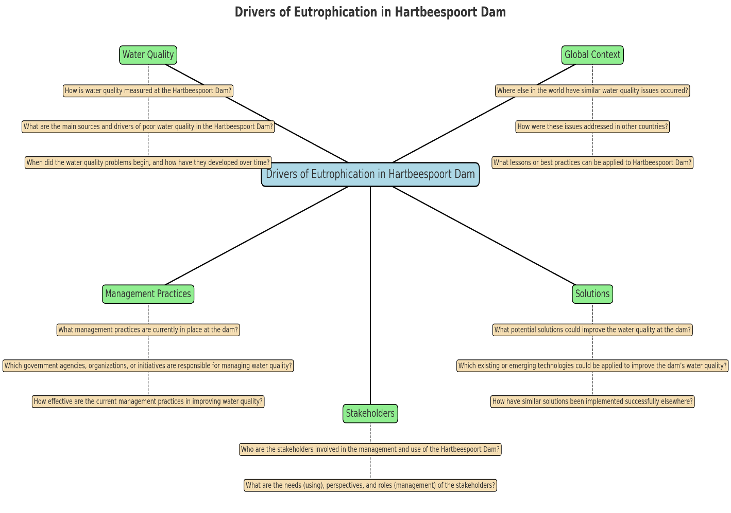

How is water quality measured at the Hartbeespoort Dam?

What are the main sources and drivers of poor water quality in the Hartbeespoort Dam?

When did the water quality problems begin, and how have they developed over time?

Where else in the world have similar water quality issues occurred?

How were these issues addressed in other countries?

What lessons or best practices can be applied to Hartbeespoort Dam?

What management practices are currently in place at the dam?

Which government agencies, organizations, or initiatives are responsible for managing water quality?

How effective are the current management practices in improving water quality?

What potential solutions could improve the water quality at the dam?

Which existing or emerging technologies could be applied to improve the dam’s water quality?

How have similar solutions been implemented successfully elsewhere?

Who are the stakeholders involved in the management and use of the Hartbeespoort Dam?

What are the needs (using), perspectives, and roles (management) of the stakeholders?

1. How is water quality at Hartbeespoort Dam assessed, and what are the main sources driving its decline:

industrial and municipal wastewater discharge, agricultural runoff, and mining activities

1. When did water quality issues begin, and how have they evolved over time:

issues were well-established by the 1970s with the presence of water hyacinth, and the problem worsened over time

1. What global examples exist of similar water quality challenges, and what lessons can be applied locally:

Lake Erie (USA/Canada) and Lake Taihu (China)

1. What management practices and government initiatives are currently in place at the dam, and how effective are they:

South African government initiatives to manage water hyacinth at Hartbeespoort Dam include physical removal using mechanical harvesters and manual labour, as well as biological control programs involving water hyacinth weevils and nanobubbles technology to accelerate decomposition.

1. What potential solutions or technologies could improve water quality at Hartbeespoort Dam:

nutrient inputs by treating sewage, managing agricultural fertilizer use, and establishing buffer strips of vegetation. Inside the lake, methods include chemical treatments to bind phosphates, physical removal of nutrient-rich sediments, and biological solutions like biomanipulation to control algae and enhance grazers.

1. Who are the key stakeholders, and what are their roles, needs, and perspectives in managing the dam?

Design a sensor network to enable local communities and specialists also trying to solve the problem in and around the Hartbeespoort dam to monitor nitrate and phosphate levels in the dam to improve the quality of the dam’s water and decrease the rate of growth of water hyacinth.

Engagement Channels

* Community workshops & info sessions – hands-on demonstration of sensors and dashboard.
* Mobile app or SMS alerts – accessible to local communities without smartphones.
* Partnerships with NGOs/universities – provide training and scientific support.
* Government briefings – ensure data informs policy and water management.

Incentives for Adoption

* Highlight direct benefits: fewer hyacinths, better fishing, improved water quality.
* Offer community ownership programs: local teams help maintain sensors, track data.
* Publish regular reports and visual dashboards showing measurable improvements.

Marketing Messaging

* Use simple, relatable language:
  + “See what’s in your water – stop hyacinth before it chokes your lake.”
  + “Protect our dam for fishing, farming, and fun.”
* Showcase visualizations and maps – people relate more to visuals than raw data.

1. Government and Regulatory Bodies

* Department of Water and Sanitation (DWS) – main authority for water resource management.
* Department of Environmental Affairs (DEA) – responsible for biodiversity and ecosystem protection.
* North-West Provincial Government & Local Municipalities – oversee land use, wastewater management, and local development.
* South African National Parks (SANParks) – where applicable, for conservation of surrounding ecosystems.

2. Local Communities

* Residents living near the dam who depend on it for domestic water use.
* Farmers and agricultural users relying on irrigation.
* Recreational users (boating, fishing, tourism operators).

3. Industry and Economic Users

* Tourism businesses (lodges, restaurants, water sports).
* Fishing industry (both commercial and recreational).
* Agricultural sector (crop irrigation, livestock watering).
* Industries upstream that discharge wastewater (e.g., mining, manufacturing, urban runoff).

4. Environmental and Research Organizations

* NGOs working on water conservation, pollution prevention, and invasive species control.
* Universities and research institutes studying eutrophication and water quality trends.
* International organizations offering best practices (e.g., UNEP, UNESCO water initiatives).

5. Utilities & Infrastructure Operators

* Water treatment plants and wastewater facilities feeding into the Crocodile River catchment.
* Electricity providers (if hydropower is relevant, though Hartbeespoort is not a major hydro source).

How might we read phosphate levels?

How might we read nitrate levels?

How might we share the data we have found.

After receiving readings from our sensor network how might we use this information to display the data in a simple and comprehensive.

What sensor do we need to build our sensor network?

How accurate are the sensor readings?

How does the LoRa network function?

Once we have the reading how do we improve water quality?

How will our solution affect the dams’ ecosystem?

2 categories of sensors

* + Sensors reading the water quality in each river
  + Sensors reading the water quality in the dam

Rivers – trying to find which rivers are the problem.

Dam – seeing the effects?

Things we need to monitor:

* + Temp of water and area
  + Humidity of area
  + Nitrate levels
  + phosphate levels
  + PH (measure acidity